Name
Professor
Institution Affiliation
Course
Police brutality
As of late, the moves made by the police, particularly the police brutality, are causing far-reaching, open and genuine concern. Residents are stressed over shielding themselves from offenders, however, they likewise need to give close consideration to the individuals who are secured and served. In this article, we will clarify the kinds of police misconduct that are winning today, for example, the utilization of weapons and receipt of individual data. We likewise talk about how and how the police use citizenship. Police brutality alludes to purposeful word assaults and over the top assaults on the general population. This over the top power might be a type of physical or mental terrorizing.
In numerous nations around the globe, particularly in the updates on such cases, police mercilessness is self-evident. It is viewed as a police conning including sexual maltreatment, police debasement, false capture, race profiling, and political persecution. These types of police fierceness are fundamentally focused on powerless populaces, for example, poor people, the frail and the old. The greater part of these police fierceness is identified with racial separation (organization). In numerous nations, police approve capturing suspects and practising power to ensure themselves. Be that as it may, they should control each circumstance and utilize sensible capacity to accomplish their objectives, (Gross, pg.155).
Examples of police brutality
On the off chance that the police practice more power than would normally be appropriate to capture the suspect and deal with the circumstance, police fierceness will happen. The recorded proof of police mercilessness recommends that while the police open up their reason for proof identified with late homicide, the African-American family that the police stand stripped in their lounge come from the instance of Monroe versus Pap compelled to. It is a house. We cannot consider capture warrants and explanations behind this police mercilessness. The thought is that more presumes who are in danger of savage wrongdoing by regular citizens are in danger during capture and can utilize more power.
For instance, when a military officer killed non-military personnel and shot a speculate who still has a weapon, there is no police severity. A case of police fierceness is unarmed speculates fleeing from the robbery of the burglary that was shot by the police. The outrages of police are normally physical, purposeful inordinate power works out. It might likewise be an assault by police words or a mental terrorizing. In spite of the extraordinary improvement in police practice, police charges on illicit direct and misuse keep on spreading all through the nation. Today’s police mercilessness proceeds with everywhere throughout the world, the police headquarters has fortified the police ruthlessness. In 2018, police killing was evident in sacramento cops, Pittsburgh and Alabama where the individuals name below were killed as analyzed by Michael.
Group of police | Date of killing | Name of killed individuals | Age of killed individuals
Sacramento cops | March 2018 | Stephen clark | 22 years old
Pittsburgh police | June 2018 | Antwon Rose | 17 years old
Alabama police | November | Branford junior | 22 years old

Police killing based on race
Race | Percentage killed
Black | 28%
White | 48.2%
Hispanic | 16.7

There is the last draft of one proposal research paper. Police fierce police work is perilous. Some of the time the police will expand the requirement for over the top utilization of power. Be that as it may, a few authorities utilize these outrageous countermeasures without such a circumstance, police mercilessness happens. I think police mercilessness will influence everybody in our general public, so I have to comprehend it. For what reason would we be able to accept that when they utilize this abundance control they swear that "serve the general population”. Police work frequently makes hazardous and upsetting jobs for people in managing associates with criminal offences with all dimensions. For this situation, there might be occasions requiring unequivocal preparing. Police organizations have exacting rules to separate mandatory implementation into shifting degrees of seriousness.
In the event that the official uses more than admissible authorization, this physical control will be pointless excess. The police fierceness can be said to be the most evident police act, particularly in current history, (Ariel, et al, pg.520). However, everyone ought not to endure or excuse police severity. In the event that you cannot bolster the person in question, in any event, realize that the monstrosities of the police will debase the security of all the police individuals. Police savagery is increasingly hazardous in our locale. Police mercilessness disregarded all our human rights. On the off chance that we are not cooperating, we cannot dispose of it, so we need you and me with this pit. My "trump watch" day is over when my child is conceived.
Police fierceness is a standout amongst the most genuine human rights infringement in the United States and can be seen all over. The reason I picked this subject is that police fierceness is continually occurring in the US and has not been perceived by numerous individuals yet. What's more, in light of the fact that the wrongdoing is not kidding, police severity can have genuine ramifications for other police and regular folks, so the overall population needs to comprehend this issue. Police severity When individuals consider police bamboozling, there are numerous things that aren't up until now. In any case, because of the new police rules, methods, and even affable society, police misrepresentation may start to decay soon, (Nhan, pg.5).
A few concerns on the strategies underlining the utilization of power in the authorization of law have been raised. Positive conclusions, negative protests, and ambivalent sentiments about the utilization of power have differed all through people in general just as inside the criminal equity framework with regards to this approach. For various years, it has been incredibly troublesome in deciding the correct meaning of what is viewed as the utilization of power or the best possible utilization of power, particularly with respect to law implementation. Unexpectedly, there have been many investigations on police and the utilization of power and research presumed that there is no single acknowledged definition.
Must police use power?" Not just should the response to this inquiry incorporate the conditions encompassing the circumstance yet it ought to likewise incorporate the measure of power ready to be utilized in every novel circumstance. This inquiry will particularly profit a cop when deciding the measure of power that ought to be applied to criminal suspects. In general, with the goal for one to completely comprehend the different meanings of the utilization of power, one must probably welcome the foundation, causes, and approaches to decrease the utilization of power, (Gerber et al, pg.90).
Utilization of power portrays a privilege of an individual or specialist to settle clashes or avert certain activities by applying measures to either: deter another gathering from a specific game-plan, or physically mediate to stop them. Police are allowed the expert to utilize power and having the option to utilize power this describes a standout amongst the most misinterpreted forces conceded to officials of the administration. Law authorization officers may characterize the utilization of power as, taking all activities to carry an unfriendly circumstance to a progressively reasonable status.
Types of forces police use
There exist several explanations concerning the view of the top degree of force, which can fluctuate from utilizing bean packs weapons, compound splash, or cudgel. Once these tools are utilized inappropriately or unreasonably it may be stated that they are utilizing them due to their level of power. Nevertheless since they are non-destructive they can be seen as reasonable usage of intensity. In this way, the proportion of intensity a cop uses does not only depend upon oneself, be that as it may, his or her watchfulness. Every condition that maybe incorporates the usage of intensity is remarkable. Conditions may be tantamount or seem to mirror one another; nonetheless, no situation is the proportionate. By conditions transforming from the refinements in people, territories, feelings, and establishments to tailor a particular definition, make certain guidelines for the usage of intensity is irksome, (Ariel, et al, pg.520). See the pictures of how police brutally harasses residents
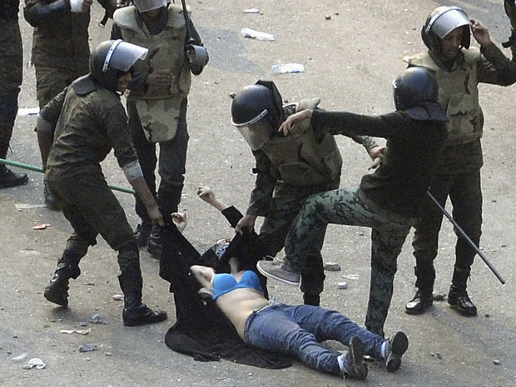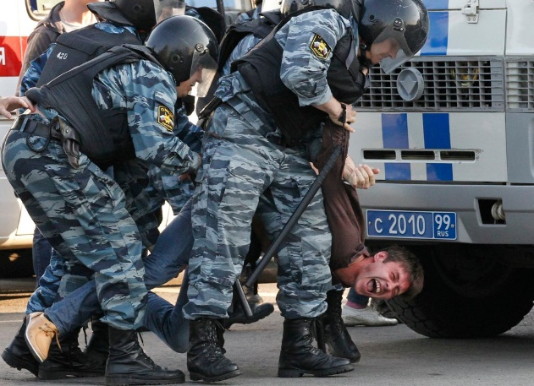
When dealing with specific circumstance cops have an assortment of power choices from which they can pick. Police have been conceded the expert to use both physical and mental authority to settle wrongdoings and keep lawbreakers. At the particular event, hooligans can be useful when being caught, so there is no necessity for physical power the immaterial closeness of the officer is adequate to get their control. Right when wrongdoers are no so accommodating, the underlying advance would be verbal bearings, proceeding the accompanying stage to keep a criminal, would be the consistency hold which means applying physical power, which may be trailed by the use of non-lethal weapons, for instance, the bar or Tasers. The last result would resort in applying savage power, which by all strategies should try to be avoided with the exception of whenever pondered essential.
Causes of police brutality and excessive use of power
The real reason for abuse of power, potentially prompting police fierceness is that cops are seen as "fighters" in a "war" on offense. The war mindset driving forces are to do certain things that would not be permitted under typical conditions. Police receive this mindset in light of residents, whose dread of wrongdoing has achieved an unequalled high, and as a result of lawmakers, who advertise the idea that intense cops avert wrongdoing. Most suspects are pleasing and expect near a controlling arm, anyway the people who decay or restrict, and now and then the people who don't, may instigate an enticing response. Subjects of police work of intensity normally respond with charges of law necessity wildness. Once in a while these cases are unjustifiable, an aftereffect of misguided judgment what may legitimize legitimate power or of the tricky charge, (Worden, pg.150).
The war mindset driving forces are to do certain things that would not be permitted under typical conditions. Police receive this attitude as a result of natives, whose dread of wrongdoing has achieved an unsurpassed high, and due to government officials, who advertise the idea that extreme cops anticipate wrongdoing. Most suspects are agreeable and require no more times they speak to a simple interest for acknowledgement and change for harmed bodies and spirits. The difficulty is the absence of a reasonable concurrence on what establishes real utilization of power.
People in general, just as the police force, know that in certain situations, supremacy isn't just important and unavoidable, yet is require if any harm, transient or decimation of possessions should be kept away from. When managing regular citizen allies and the entirety with the force police can use during an arrest it places them in a temperamental situation. At the point when cops settle on choices and decisions dependent on the present circumstance without alluding to any strategies and techniques, just by following one's own judgment this is called attentiveness. This gives the police slack about when power is essential and when it isn't, inside specific rules, (Gross, pg.155).
Ways to reduce police brutality
There are different ways to diminish the inordinate use and inappropriate utilization of authority, the greatest significant factor is to create enforceable laws to the furthest reaches of explanations. Cops should fall under these identical game plans of rules, they should be used as anticipation so various officers won't complete this equal bad behavior later on. It's definitely not an issue of should or whether anyway when and how much. In any case, cops must make sense of how to use control really. You can't use destructive power uninhibitedly or use control when it isn't permitted. The Continuum Scale is acknowledged to be a champion among the most gainful sources used to ensure the reasonable proportion of intensity is used, (Cooper, et al, pg.8). Literary, people should join up and say “No police brutality”. Demonstration can also be used in specific context. Further, one can show the aspect of surrendering by kneeling down showing hands up. See the pictures below
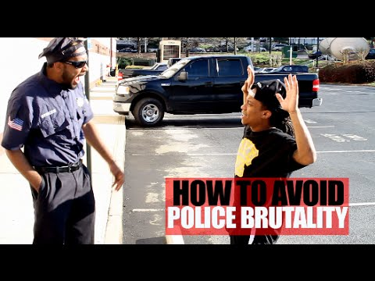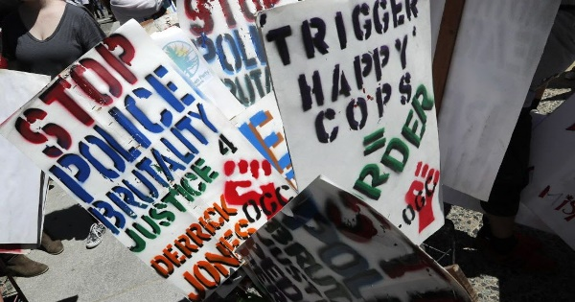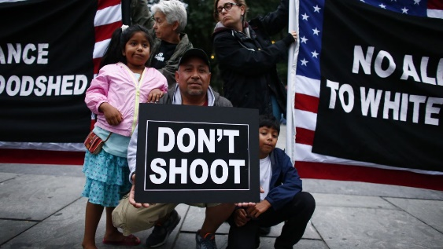

Conclusion
It is commonly regarded that the police in some irregular society have an irksome movement to fulfill. Overseeing offenders and setting themselves in harm’s way on a regular reason is irrefutably an admirable calling. Despite the way that seen as irksome, there is a fundamental idea in the general populace that the movement of law execution officers is tolerably clear. Police are looked with extraordinary great decisions step by step. They are to pick when and adequate conduct when given encroachment of the law. Right when the usage of intensity outperforms, what is essential to accomplish their real reason, or when their inspiration isn't legitimate stress or self-assurance in the meantime, somewhat near and dear striking back, it is portrayed as extraordinary use of intensity and is corrupt and unlawful.
Work cited
Worden, Robert E. "The ‘causes’ of police brutality: theory and evidence on police use of force." ER Maguire, & DE Duffee, Criminal Justice Theory: Explaining the Nature and Behavior of Criminal Justice 2 (2015): 149-204.
Nhan, Johnny. "Police culture." The encyclopedia of criminology and criminal justice (2014): 1-6.
Ariel, Barak, William A. Farrar, and Alex Sutherland. "The effect of police body-worn cameras on use of force and citizens’ complaints against the police: A randomized controlled trial." Journal of quantitative criminology 31.3 (2015): 509-535.
Gross, John P. "Judge, jury, and executioner: The excessive use of deadly force by police officers." Tex. J. on CL & CR 21 (2015): 155.
Gerber, Monica M., and Jonathan Jackson. "Justifying violence: legitimacy, ideology and public support for police use of force." Psychology, Crime & Law 23.1 (2017): 79-95.
Cooper, Hannah LF, and Mindy Fullilove. "Excessive police violence as a public health issue." Journal of urban health93.1 (2016): 1-7.

Michael Harriot.Here’s How Many People Police Killed in 2018. https://www.theroot.com/here-s-how-many-people-police-killed-in-2018-1831469528

